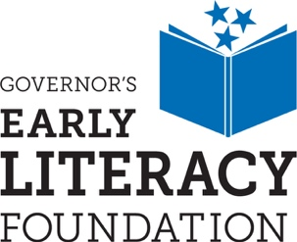

Governor’s Early Literacy Foundation
Social Media Kit
October 2021

ART | Recommended Post Date | Recommended Post Text
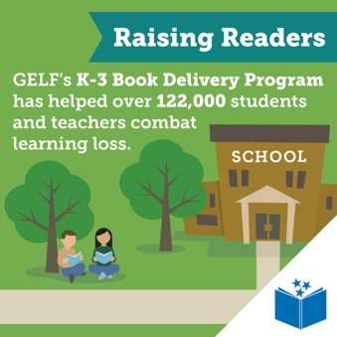 | Oct 8 | Governor’s Early Literacy Foundation’s K–3 Book Delivery program has delivered over 1 million books to more than 122,000 Tennessee students and teachers, at no cost to parents or schools. To find out how you can support early literacy in TN, visit governorsfoundation.org
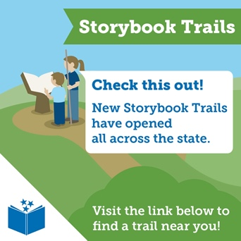 | Oct 14 | Governor’s Early Literacy Foundation is opening new Storybook Trails for you and your family to explore. Take your reading outside and enjoy the fall weather this season! Visit governorsfoundation.org /storybook-trails to find a trail near you.
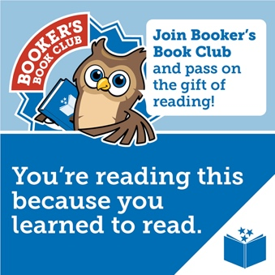 | Oct 21 | You’re reading this because you learned to read! Join Bookers Book Club and help give the gift of #reading to a Tennessee child. Go to governorsfoundation.org to learn about the different ways you can support early literacy across TN.
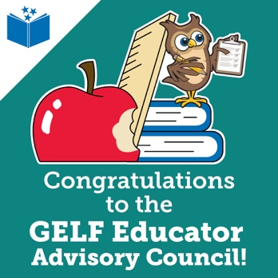 | Oct 28 | Congratulations to the educators chosen to participate in Governor’s Early Literacy Foundation’s Educator Advisory Council! These professionals will be working to ensure that Tennessee’s K–3 students have their literacy needs met. For more information, visit governorsfoundation.org/teacher-advisory-council

